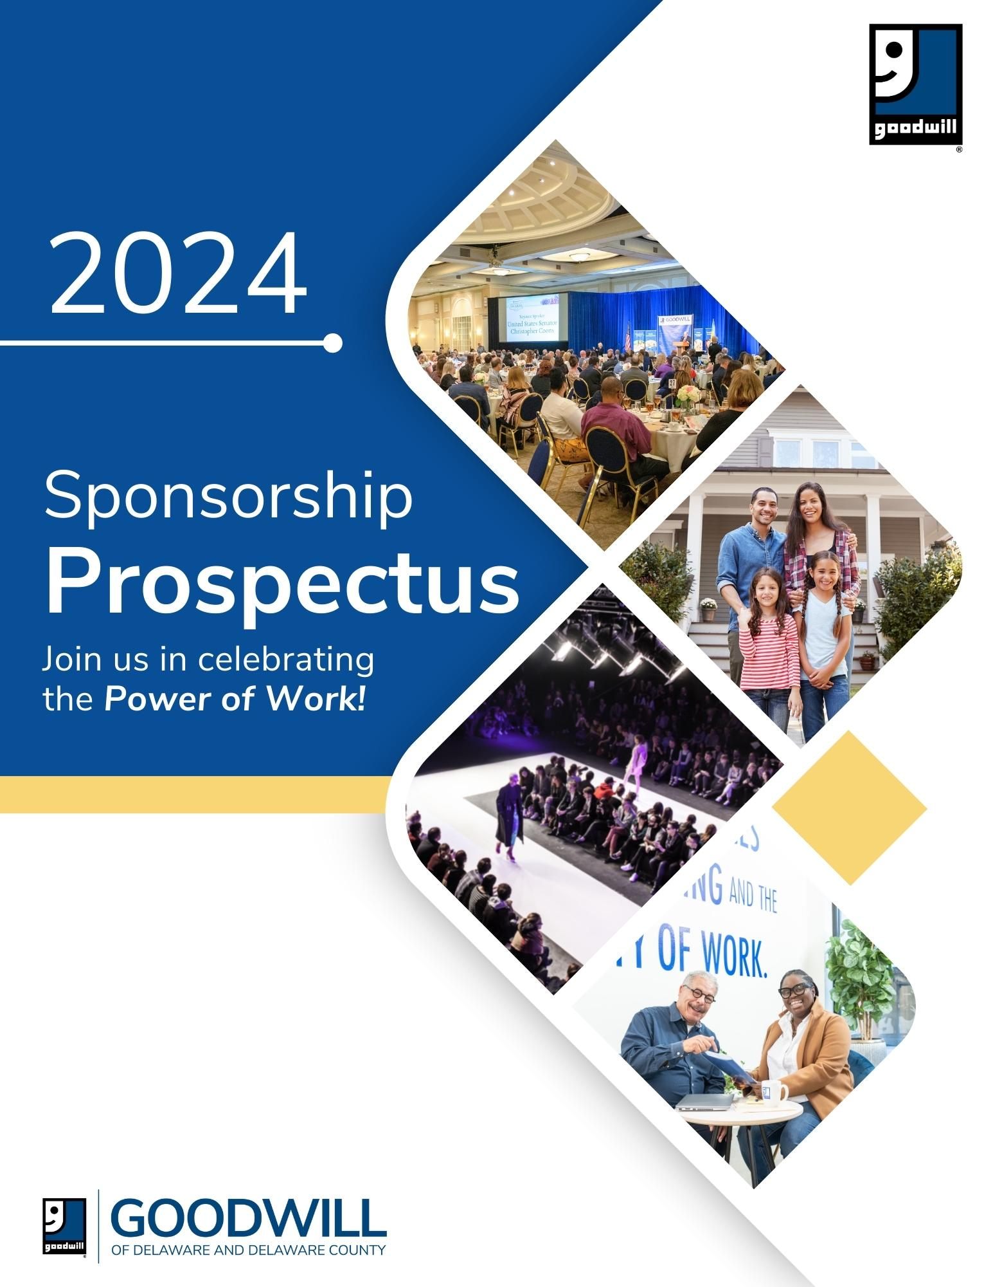

**Contact Us!**

Leah Williams

Vice President, Brand & Community Engagement

302-504-3554 • [Leah.Williams@GoodwillDE.org](mailto:Leah.Williams@GoodwillDE.org)

**2024 Goodwill Inspiration Awards**

**Sponsorship Prospectus**

The Goodwill Inspiration Awards Luncheon celebrates and recognizes individuals, organizations and businesses that reflect Goodwill’s mission of removing barriers to self-sufficiency through the ***Power of Work***.

**Please join us, Friday, May 10, 2024, at the Chase Center in Wilmington, Delaware** to celebrate our program participants and team members, businesses and community organizations, while raising awareness and funds to support our non-profit mission!

The luncheon is attended by nearly 400 leaders from the business, non-profit, and government sectors throughout the four counties we serve.

Since 2012 our sponsors and luncheon attendees have included:

Action Unlimited Resources

Aetna

Ameriprise Financial Services, Inc

Ancero

Apex Engineering

Arkieva

Artisans' Bank

Atlantic Trailer

Bank of America

Barbacane Thornton and Co.

BDO USA

Biddle Capital Management

Breckstone Architecture

CBM IFS Insurance

Christiana Health Care System

CIGNA

Citizens Bank

City of Wilmington/City Council

Comcast

Corporation Service Company

Crozer-Chester Medical Center

Delaware Community Foundation

Delaware Today/Today Media

Delmarva Blood Bank

Delaware State Chamber of Commerce

Delmarva Broadcasting

Delmarva Power

Del-One Federal Credit Union

Diamond Technologies

Du Pont

Eckert Seamans Cherin & Mellot

EDiS Company

Emory Hill Companies

Fidelitrade

Glenmede

Gordy Management

Growth Consulting, Inc

Gunnip & Company CPAs

Harvey Hanna and Associates

Highmark Delaware

IFS Benefits

KING Creative

Laird Stabler & Associates

Lewis Brisbois Bisgaard & Smith

McCollum D’Emilio Smith Uebler

Monroe Energy

M&T Charitable Foundation

National Reality Corporation

New Castle County Chamber of Commerce

New Castle County Executive

Patterson Woods

PayCom

Pennoni

Pettinaro

Philadelphia Pike Partners

PNC Bank

PwC

Prospero Consulting

Quantum Controls

Richards Layton & Finger

RSS Consultants

Santora CPA Group

Saul Ewing

Savoy Associates

Simkiss & Block

Sir Speedy/Pop Dot

Sonitrol Security of Delaware

Studio JAED

TD Bank

The Kenny Family ShopRites

The MandMarblestone Group

The WRK Group

Tsionas Management, Inc

United Healthcare

Upper Darby Township

Upright Labs

Waste Management

Weiner Benefits Group

Whisman Giordano & Associates

Wohlsen Construction

WSFS Bank

Wilmington Alliance

Wilmington University

Year Up

**Align your organization’s brand with Goodwill’s *vision of empowering people, strengthening families, and building communities*, through a luncheon sponsorship.**

As a sponsor of the Goodwill Inspiration Awards, your organization will enjoy networking opportunities and brand visibility with the nearly 400 luncheon attendees from the business, non-profit and government sectors, as well as visibility to our shoppers, donors and supporters:

|  |  |
| --- | --- |
| * Social media audience: 27,000+ followers | * GoodPerks email subscribers: 20,000+ |

**Goodwill Inspiration Awards Luncheon Sponsorship Packages**

*Custom sponsorships are available.*

**$10,000 INSPIRATION Premier Sponsor**

* Opportunity for company leadership to address luncheon audience from the podium
* Sponsor logo featured in all award recipient videos
* Sponsor logo on all event materials: program, table signs, sponsor signage and slides
* Brand recognition in all pre-event marketing (name & logo)
* Premier sponsor listing in all press releases
* Photo opportunity with all award recipients
* Two tables Premier seating, 16 seats total
* Recognition in one Good Perks email, Inspiration Awards edition
* Recognition in six GoodPerks loyalty program emails (every other month). Each GoodPerks email is delivered to more than 20k subscribers.
* 450-minutes of advertising time on Goodwill store radio (17 locations).

**$5,000 EMPOWER Sponsor**

* Sponsor logo on event materials: program, table signs, sponsor signage and slides
* Brand recognition in all pre-event marketing (name & logo)
* Verbal recognition at event
* 2 Tables Premier seating, 16 seats total
* Recognition in one Good Perks email, Inspiration Awards edition
* Recognition in four GoodPerks loyalty program emails delivered to 20k+ subscribers.
* 250-minutes of advertising time on Goodwill store radio (17 locations).

**$3,200 IMPACT Sponsor**

* Sponsor logo on select event materials: program, sponsor signage and slides
* Brand recognition in all pre-event marketing (name & logo)
* Verbal recognition at event
* 1 Table, Preferred seating, 8 seats
* Recognition in one Good Perks email, Inspiration Awards edition

**$2,000 ENERGIZE Sponsor**

* Logo on event website
* Logo on sponsor signage and slides at the luncheon
* Name listing in the luncheon program
* 1 Table, reserved seating for 8
* Recognition in one Good Perks email, Inspiration Awards edition

**$1,300 POWER OF WORK Table Host**

* Name listing in the luncheon program
* 1 Table, reserved seating for 8
* Recognition in one Good Perks email, Inspiration Awards edition

**$750 ENCOURAGE Supporter**

* Name listing in the luncheon program
* Reserved seating for 4

**$350 MISSION Supporter**

* Name listing in the luncheon program
* Reserved seating for 2

**$125 GOODWILL Friend**

* 1 reserved seat

Your sponsorship dollars help to advance our non-profit mission of improving the lives of people facing barriers to self-sufficiency, through the ***Power of Work!***

To sign on as a sponsor please contact Leah Williams or visit [www.GoodwillDE.org/Sponsorship](http://www.GoodwillDE.org/Sponsorship).

Goodwill of Delaware & Delaware County is a 501(c)(3) charitable organization and donations are tax deductible to the extent allowed by the IRS. Our Federal ID number is 51-0064311.

Thank you for considering sponsorship of the 2023 Goodwill Inspiration Awards. We look forward to partnering with you!

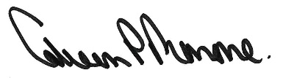

|  |  |
| --- | --- |
|  |  |

Colleen Morrone Leah B. Williams

President & CEO Vice President, Brand & Community Engagement

Goodwill of Delaware and Delaware County Goodwill of Delaware and Delaware County

cmorrone@GoodwillDE.org | 302-504-5734 leah.williams@GoodwillDE.org | 302-504-3554

